Models

using System.ComponentModel.DataAnnotations;
using System.ComponentModel.DataAnnotations.Schema;
using TechLaptop.Repository.Validation;

namespace TechLaptop.Models // Class này bỏ vào Dbcontext thực hiện Add-Migration và Update-Database
{
public class ContactModel{
[Key]
public int Id { get; set; }

[Required]
public string ShopName { get; set; }

[Required]
public string Map { get; set; }

[Required]
public string Phone { get; set; }

[Required]
public string Email { get; set; }

[Required]
public string Address { get; set; }

[Required]
public string Description { get; set; }

public string LogoImage { get; set; } = "noimage.jpg";

[FileExtension] // áp dụng Attribute đã tạo
[NotMapped]
public IFormFile? ImageUpload { get; set; }

}
}

Controllers

using Microsoft.AspNetCore.Authorization;
using Microsoft.AspNetCore.Hosting;
using Microsoft.AspNetCore.Mvc;
using Microsoft.AspNetCore.Mvc.Rendering;
using Microsoft.EntityFrameworkCore;
using TechLaptop.Models;
using TechLaptop.Repository;
namespace TechLaptop.Areas.Admin.Controllers
{
[Area("Admin")]
[Authorize]
public class ContactController : Controller
{
private readonly DataContext _dataContext;
private readonly IWebHostEnvironment _webHostEnvironment;
public ContactController(DataContext _context, IWebHostEnvironment webHostEnvironment)
{
_dataContext = _context;
_webHostEnvironment = webHostEnvironment;
}
public async Task <IActionResult> Index(int pg)
{
var contacts = await _dataContext.Contacts.ToListAsync();
ViewBag.Count = contacts.Count;
return View(contacts);

}

[HttpGet]
public async Task<IActionResult> Create()
{
return View();
}

[HttpPost]
[ValidateAntiForgeryToken]
public async Task<IActionResult> Create(ContactModel contact)
{
List<string> errors = new List<string>();
if (ModelState.IsValid)
{

if (contact.ImageUpload != null)
{
string uploadsDir = Path.Combine(_webHostEnvironment.WebRootPath, "media/logo");
string imageName = Guid.NewGuid().ToString() + "_" + contact.ImageUpload.FileName;
string filePath = Path.Combine(uploadsDir, imageName);

FileStream fs = new FileStream(filePath, FileMode.Create);
await contact.ImageUpload.CopyToAsync(fs);
fs.Close();

contact.LogoImage = imageName;

}

_dataContext.Contacts.Add(contact);
await _dataContext.SaveChangesAsync();

TempData["Success"] = "thành công";
return RedirectToAction("Index", "Contact");

}
else
{
TempData["Error"] = "Không thành công";

foreach (var value in ModelState.Values)
{
foreach (var error in value.Errors)
{
errors.Add(error.ErrorMessage);
}
}
string errorMessage = string.Join("\n", errors);

}

return View(contact);

}

[HttpGet]
public async Task<IActionResult> Edit(int Id)
{
var contact = await _dataContext.Contacts.FindAsync(Id);
return View(contact);
}

[HttpPost] // Chỉ nhận POST requests
[ValidateAntiForgeryToken]
public async Task<IActionResult> Edit( ContactModel contact)
{
var existed_contact = _dataContext.Contacts.Find(contact.Id); // tìm sp theo Id

List<string> errors = new List<string>();
if (ModelState.IsValid)
{

if (contact.ImageUpload != null)
{
string uploadsDir = Path.Combine(_webHostEnvironment.WebRootPath, "media/logo");
string imageName = Guid.NewGuid().ToString() + "_" + contact.ImageUpload.FileName;
string filePath = Path.Combine(uploadsDir, imageName);

FileStream fs = new FileStream(filePath, FileMode.Create);
await contact.ImageUpload.CopyToAsync(fs);
fs.Close();

existed_contact.LogoImage = imageName;

}
// Update dua tren Id
existed_contact.ShopName = contact.ShopName;
existed_contact.Map = contact.Map;
existed_contact.Phone = contact.Phone;
existed_contact.Email = contact.Email;
existed_contact.Description = contact.Description;

_dataContext.Contacts.Update(existed_contact);
await _dataContext.SaveChangesAsync();

TempData["Success"] = "Cập nhật thành công";
return RedirectToAction("Index", "Product");

}
else
{
TempData["Error"] = "Không thành công";
foreach (var value in ModelState.Values)
{
foreach (var error in value.Errors)
{
errors.Add(error.ErrorMessage);
}
}
string errorMessage = string.Join("\n", errors);

}

return View(contact);
}
[HttpGet]
public async Task<IActionResult> Delete(int Id)
{

ContactModel contact = await _dataContext.Contacts.FirstOrDefaultAsync(p => p.Id == Id);

if (contact == null)
{
return NotFound();
}

if (!string.Equals(contact.LogoImage, "noname.jpg"))
{
string uploadsDir = Path.Combine(_webHostEnvironment.WebRootPath, "media/logo");
string oldfilePath = Path.Combine(uploadsDir, contact.LogoImage);

if (System.IO.File.Exists(oldfilePath))
{
System.IO.File.Delete(oldfilePath);

}
}
_dataContext.Contacts.Remove(contact);
await _dataContext.SaveChangesAsync();

TempData["Error"] = "Sản phẩm đã xóa";

return RedirectToAction("Index", "Contact");

}
}
}

Views
Index

@model List<TechLaptop.Models.ContactModel>
@{
int count = ViewBag.Count;

}
@if (count == 0 ) {
<a asp-area="Admin" asp-action="Create" asp-controller="Contact">Add Contact</a>
}

<table class="table" id="myTable">
<thead>
<tr>
<th scope="col">#</th>
<th scope="col">Shop Name</th>
<th scope="col"> Map</th>
<th scope="col"> Phone</th>
<th scope="col"> Logo </th>
<th scope="col">Email</th>
<th scope="col">Description</th>
<th scope="col">Manage Contact </th>
</tr>

</thead>
<tbody>
@foreach (var item in Model)
{
<tr>
<td>#</td>
<td>@item.ShopName</td>
<td>
<div class="map-small-container">
@* Class này sẽ áp dụng các quy tắc width/height từ file CSS *@
@Html.Raw(@item.Map) // hiện thị ra được bản đồ
</div>
</td>
<td>@item.Phone</td>
<td> <img src="~/media/logo/@item.LogoImage" alt="mô tả ảnh" width="190" height="130"> </td>
<td>@item.Email</td>
<td>@Html.Raw(@item.Description)</td>

<td>
<a asp-area ="Admin" asp-action="Edit" asp-controller="Contact" asp-route-Id="@item.Id" class="btn btn-warning btn-sm">Edit</a>
<a asp-area="Admin" asp-action="Delete" asp-controller="Contact" asp-route-Id="@item.Id" class="btn btn-danger btn-sm confirmDeletion">Delete</a>
</td>

</tr>
}

</tbody>
</table>

@section Scripts {
<script>
let table = new DataTable('#myTable', {
layout: {
topStart: {
buttons: ['copy', 'csv', 'excel', 'pdf', 'print']
}
}
});

</script>
}

Edit

@model TechLaptop.Models.ContactModel

<h3> Edit Contact </h3>
<div class="col-md-9">
<form asp-area="Admin" asp-action="Edit" asp-controller="Contact" enctype="multipart/form-data">
<div asp-validation-summary="ModelOnly" class="text-danger"> </div>

<div class=" form-group">
<label>ShopName</label>
<input asp-for="ShopName" class="form-control" />
<span asp-validation-for="ShopName" class="text-danger"> </span>

</div>

<div class=" form-group">
<label>Map</label>
<input asp-for="Map" class="form-control" />
<span asp-validation-for="Map" class="text-danger"> </span>

</div>

<div class=" form-group">
<label>Phone</label>
<input asp-for="Phone" class="form-control" />
<span asp-validation-for="Phone" class="text-danger"> </span>

</div>

<div class=" form-group">
<label>Email</label>
<input asp-for="Email" class="form-control" />
<span asp-validation-for="Email" class="text-danger"> </span>

</div>

<div class=" form-group">
<label>Description</label>
<textarea asp-for="Description" class="form-control"> </textarea>
<span asp-validation-for="Description" class="text-danger" />

</div>

<div class=" form-group">
<label>Image </label>
<input asp-for="ImageUpload" class="form-control" />
<span asp-validation-for="ImageUpload" class="text-danger"> </span>

<img id="imgpreview" />

</div>

<div class=" form-group">

<button class="btn btn-primary">Update</button>

</div>

</form>
<a asp-area="Admin" asp-action="Index" asp-controller="Contact"> Back to Contact page</a>
</div>

@section Scripts {
@{
await Html.PartialAsync("_ValidationScriptsPartial");
}
<script src="https://cdn.ckeditor.com/4.22.1/standard/ckeditor.js"></script>

<script>
$("#ImageUpload").change(function(){
readURL(this);
})

</script>

<script>
CKEDITOR.replace('Description');

</script>
}

Create
@model TechLaptop.Models.ContactModel

<h3> Create Contact </h3>
<div class="col-md-9">
<form asp-area="Admin" asp-action="Create" asp-controller="Contact" enctype="multipart/form-data">
<div asp-validation-summary="ModelOnly" class="text-danger"> </div>

<div class=" form-group">
<label>ShopName</label>
<input asp-for="ShopName" class="form-control" />
<span asp-validation-for="ShopName" class="text-danger"> </span>

</div>

<div class=" form-group">
<label>Map</label>
<input asp-for="Map" class="form-control" />
<span asp-validation-for="Map" class="text-danger"> </span>

</div>

<div class=" form-group">
<label>Phone</label>
<input asp-for="Phone" class="form-control" />
<span asp-validation-for="Phone" class="text-danger"> </span>

</div>

<div class=" form-group">
<label>Email</label>
<input asp-for="Email" class="form-control" />
<span asp-validation-for="Email" class="text-danger"> </span>

</div>

<div class=" form-group">
<label>Description</label>
<textarea asp-for="Description" class="form-control"> </textarea>
<span asp-validation-for="Description" class="text-danger" />

</div>

<div class=" form-group">
<label>Image </label>
<input asp-for="ImageUpload" class="form-control" />
<span asp-validation-for="ImageUpload" class="text-danger"> </span>

<img id="imgpreview" />

</div>

<div class=" form-group">

<button class="btn btn-primary">Create</button>

</div>

</form>
<a asp-action="Index" asp-controller="Contact"> Back to Contact page</a>
</div>

@section Scripts {
@{
await Html.PartialAsync("_ValidationScriptsPartial");
}
<script src="https://cdn.ckeditor.com/4.22.1/standard/ckeditor.js"></script>

<script>
$("#ImageUpload").change(function(){
readURL(this);
})

</script>

<script>
CKEDITOR.replace('Description');

</script>
}

Lưu iframe

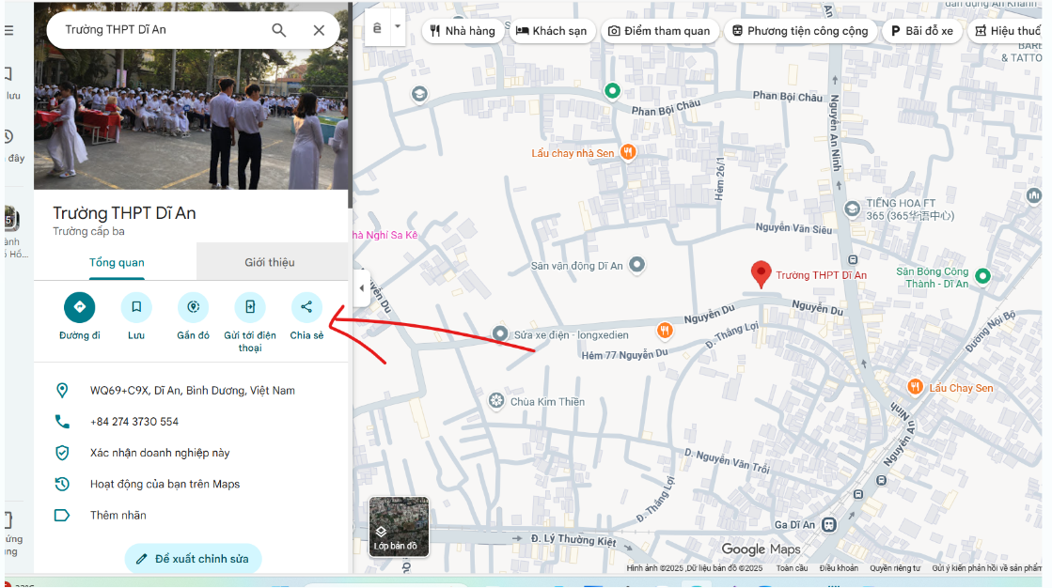

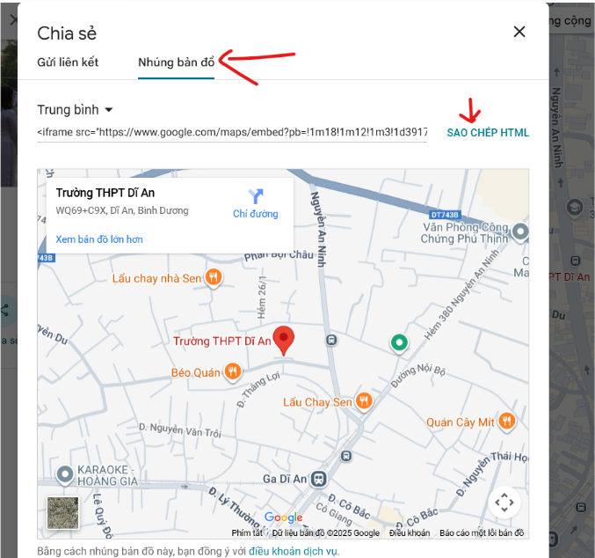

<iframe src="https://www.google.com/maps/embed?pb=!1m18!1m12!1m3!1d3919.887633771228!2d106.69896047481757!3d10.743142789403596!2m3!1f0!2f0!3f0!3m2!1i1024!2i768!4f13.1!3m3!1m2!1s0x31752f9fa1b72f8b%3A0x26780c08db949052!2zxJDhuqFpIGjhu41jIE5ndXnhu4VuIFThuqV0IFRow6BuaCBDxqEgc-G7nyBOZ3V54buFbiBI4buvdSBUaOG7jQ!5e0!3m2!1svi!2s!4v1765503682030!5m2!1svi!2s" width="600" height="450" style="border:0;" allowfullscreen="" loading="lazy" referrerpolicy="no-referrer-when-downgrade"></iframe>

Contact Page

using System.Diagnostics;
using Microsoft.AspNetCore.Mvc;
using TechLaptop.Models;
using TechLaptop.Repository;

namespace TechLaptop.Controllers
{
public class HomeController : Controller
{
private readonly DataContext _dataContext;

private readonly ILogger<HomeController> _logger;

public HomeController(ILogger<HomeController> logger, DataContext _context)
{
_logger = logger;
_dataContext = _context;
}

[HttpGet]
public IActionResult Contact()
{
var contact = _dataContext.Contacts.FirstOrDefault();
return View(contact);
}

}
}

Views
Home
@model TechLaptop.Models.ContactModel

@{
// Thiết lập Layout chung cho trang web
Layout = "~/Views/Shared/_Layout.cshtml";
ViewBag.Title = "Thông Tin Liên Hệ";
}

<style>
/* ------------------------------------- */
/* CSS Cục Bộ cho View (Không thay đổi) */
/* ------------------------------------- */

/* Thiết lập font cơ bản */
.contact-container {
font-family: Arial, sans-serif;
line-height: 1.6;
color: #333;
max-width: 1200px;
margin: 0 auto;
padding: 40px 20px;
}

/* Phần tiêu đề */
.header-section h3 {
font-size: 16px;
font-weight: bold;
color: #333;
margin-bottom: 5px;
}

.header-section h2 {
font-size: 28px;
color: #4CAF50; /* Màu xanh lá tương tự như ảnh */
margin-bottom: 20px;
font-weight: normal;
border-bottom: 2px solid #4CAF50; /* Đường gạch dưới màu xanh lá */
display: inline-block; /* Chỉ gạch dưới chữ */
padding-bottom: 5px;
}

/* Thông tin liên hệ */
.contact-info {
font-size: 14px;
margin-bottom: 30px;
}

.contact-info p {
margin: 5px 0;
}

/* Bố cục chính: chia 2 cột */
.main-content {
display: flex;
gap: 40px;
flex-wrap: wrap;
}

.left-panel {
flex: 2;
min-width: 300px;
}

.right-panel {
flex: 1;
min-width: 350px;
max-width: 500px;
}

/* Tài khoản ngân hàng (Giữ lại CSS nhưng sẽ không dùng HTML) */
.bank-account h3, .policies-section h3 {
font-size: 16px;
color: #333;
margin-bottom: 15px;
font-weight: bold;
}

/* Chính sách */
.policies-section {
/* Bỏ margin-top nếu không còn phần bank-account,
hoặc giữ nếu muốn khoảng cách với contact-info ở trên */
margin-top: 0px; /* Điều chỉnh lại khoảng cách */
}

.policies-grid {
display: grid;
grid-template-columns: repeat(2, 1fr);
gap: 10px 20px;
font-size: 14px;
}

.policies-grid a {
text-decoration: none;
color: #333;
}

.policies-grid a:hover {
color: #007bff;
text-decoration: underline;
}

/* Bản đồ */
.map-container {
border: 1px solid #ddd;
padding: 15px;
border-radius: 5px;
box-shadow: 0 0 10px rgba(0, 0, 0, 0.1);
}

.map-info {
margin-bottom: 10px;
font-size: 14px;
}

.map-info p {
margin: 0;
}

.map-link-group {
display: flex;
justify-content: space-between;
margin-top: 5px;
}

.map-link-group a {
color: #007bff;
text-decoration: none;
}

.map-iframe {
width: 100%;
height: 300px;
border: none;
border-radius: 3px;
background-color: #f0f0f0;
}

.footer-wave {
height: 100px;
background: linear-gradient(to right, #e0b4f8, #c662e0, #8a2be2);
clip-path: ellipse(150% 100% at 50% 100%);
margin-top: 50px;
}

/* Responsive */
@@media (max-width: 768px) {
.main-content {
flex-direction: column;
}

.left-panel, .right-panel {
min-width: 100%;
}

.policies-grid {
grid-template-columns: 1fr;
}
}
</style>

<div class="contact-container">
<div class="header-section">
<h3>THÔNG TIN LIÊN HỆ</h3>
<h2>SẴN SÀNG PHỤC VỤ KHÁCH HÀNG</h2>
<div class="contact-info">
<p><strong>Hotline:</strong> @Model.Phone - <strong>Email:</strong> @Model.Email</p>
<p><strong>Địa chỉ:</strong> @Model.Address</p>
</div>
</div>

<div class="main-content">
<div class="left-panel">

<div class="policies-section">
<h3>CÁC CHÍNH SÁCH</h3>
<div class="policies-grid">
<a href="#">Quy định sử dụng</a>
<a href="#">Vận chuyển</a>
<a href="#">Bảo mật thông tin</a>
<a href="#">Đổi trả và Hoàn tiền</a>
<a href="#">Hình thức thanh toán</a>
<a href="#">Hướng dẫn đặt hàng</a>
</div>
</div>
</div>

<div class="right-panel">
<div class="map-container">
<div class="map-info">
<p><strong>@Model.Address</strong></p>

<div class="map-link-group">
<a href="#">Xem bản đồ lớn hơn</a>
<a href="#">Chỉ đường</a>
</div>
</div>
<div class="map-small-container">
@* Class này sẽ áp dụng các quy tắc width/height từ file CSS *@
@Html.Raw(Model.Map)
</div>
</div>
</div>
</div>

<div class="footer-wave"></div>
</div>

